Neural Network and Deep Learning

Homework1

Name:Vaishnavi Kasani

Id :700754092

Github Link:

1.Implement Naïve Bayes method using scikit-learn library Use dataset available with name glass Use train_test_split to create training and testing part Evaluate the model on test part using score and

classification_report(y_true, y_pred)

Solution:

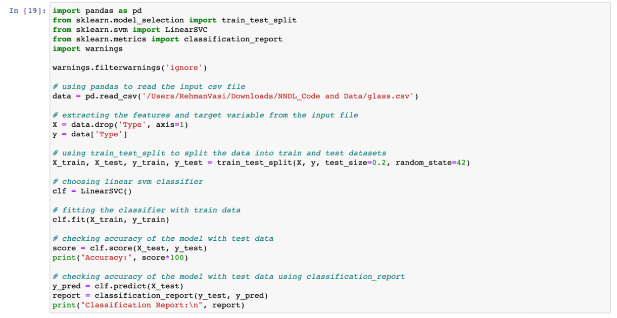

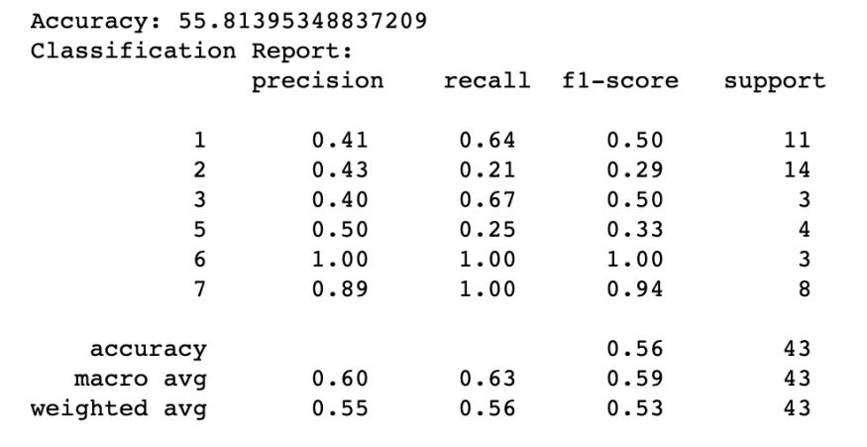

2.Implement linear SVM method using scikit-learn Use the same dataset above Use train_test_split to create training and testing part Evaluate the model on test part using score and

classification_report(y_true, y_pred)

Which algorithm you got better accuracy? Can you justify why?

Solution:

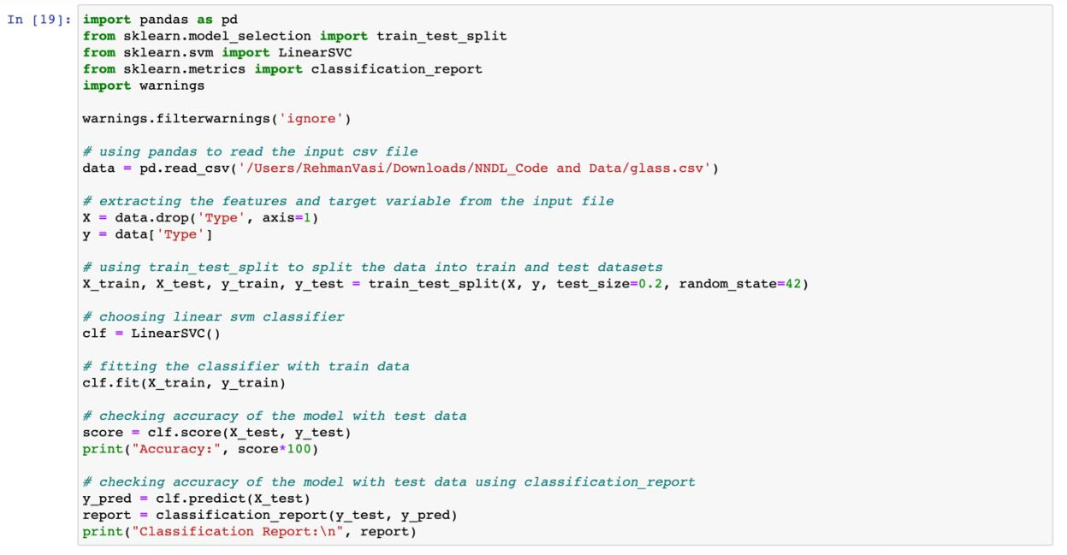

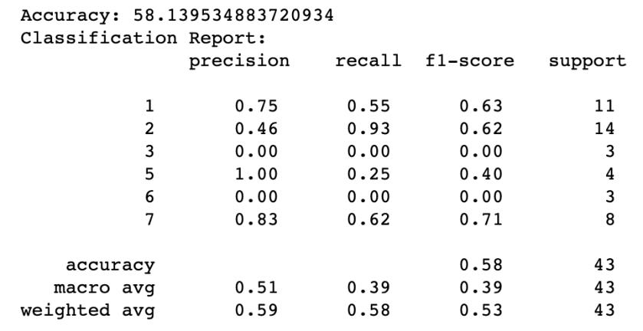

*=> SVM gave the higher accuracy ,precision and recall than the NaiveBayes .SVM have support vectors which can help in finding the maximum margin hyper plane .*

3 .Implement Linear Regression using scikit-learn

1. Import the given “Salary_Data.csv”
2. Split the data in train_test partitions, such that 1/3 of the data is reserved as test subset.

c) Train and predict the model.

d) Calculate the mean_squared error.

e) Visualize both train and test data using scatter plot.

Solution :

